Description : This Query Groups the data by marketing Channel and calculates the total spend, total revenue, and total conversions for each channel. It helps compare the performance of different marketing channels such as Facebook, Google Ads, and Email.

Query :

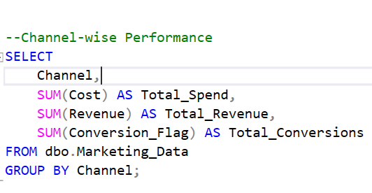

Solution :

